**P6 sceen shot**

Yong Deng

1. First run: (**password: boss. All of the non-employee’s password is simply same as the username**)

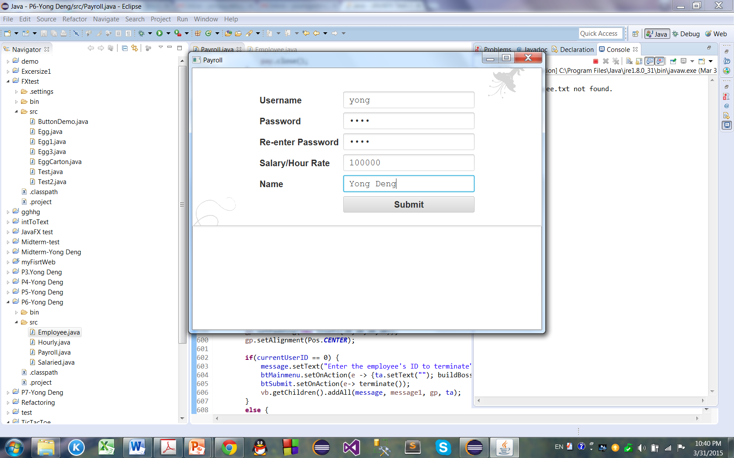

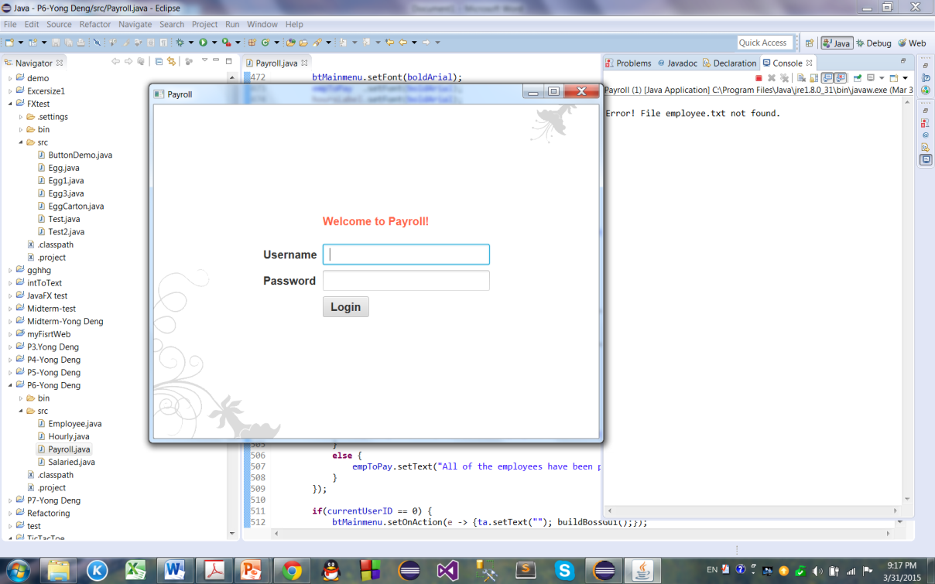2. After creating the boss:

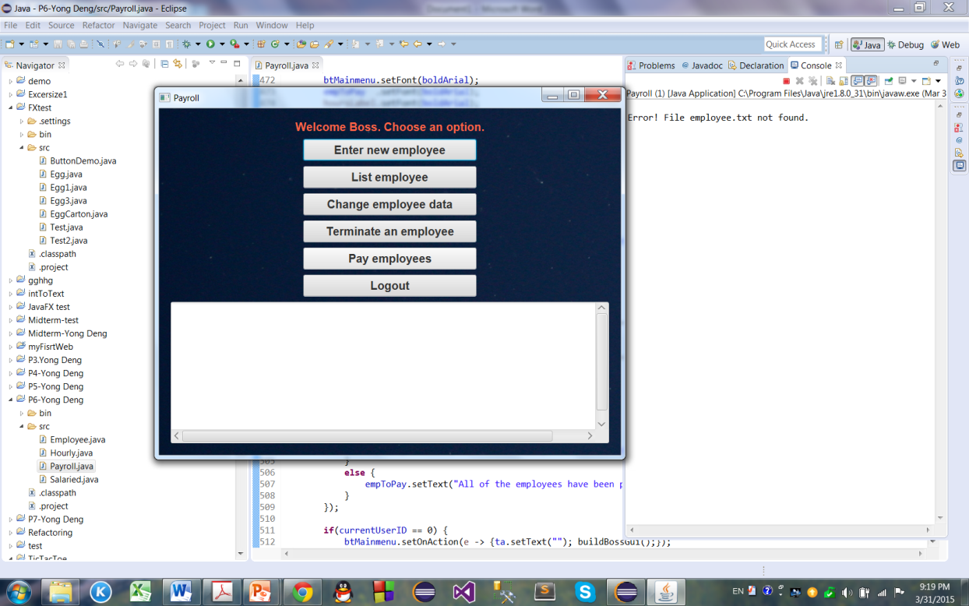3. Boss logged in the first time:

4. The boss added the first employee (**salaried**):

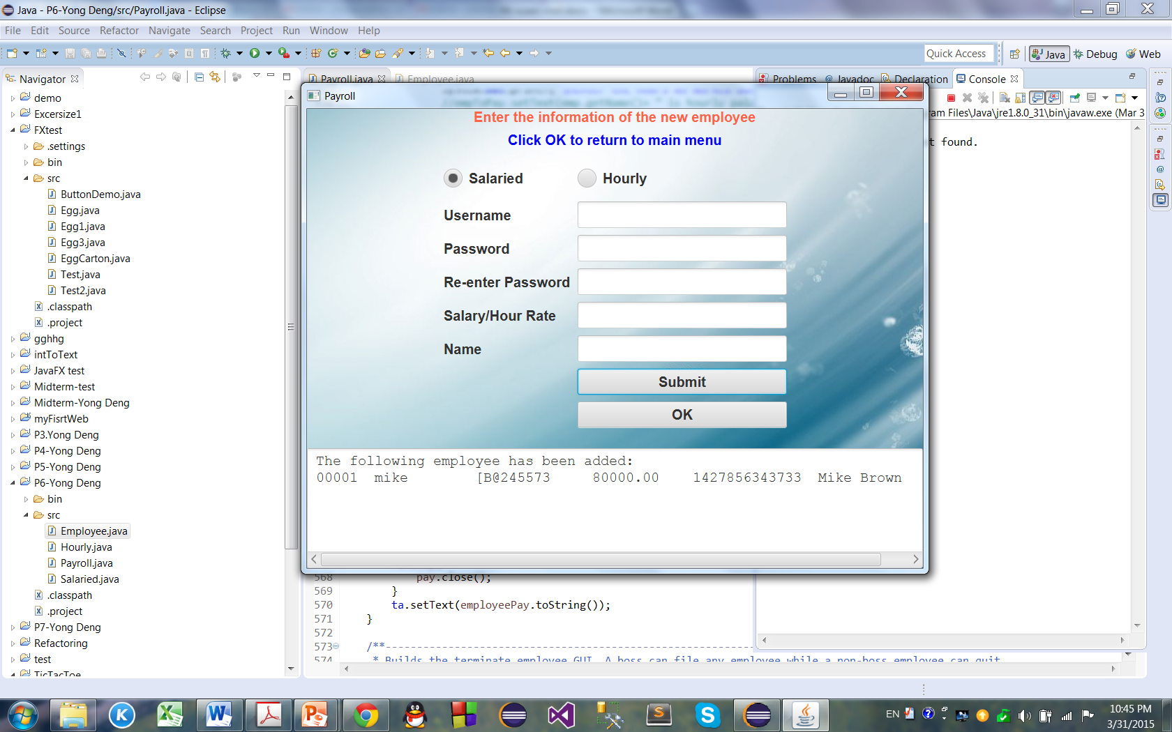

5. The second non-boss employee (**hourly paid**) added.

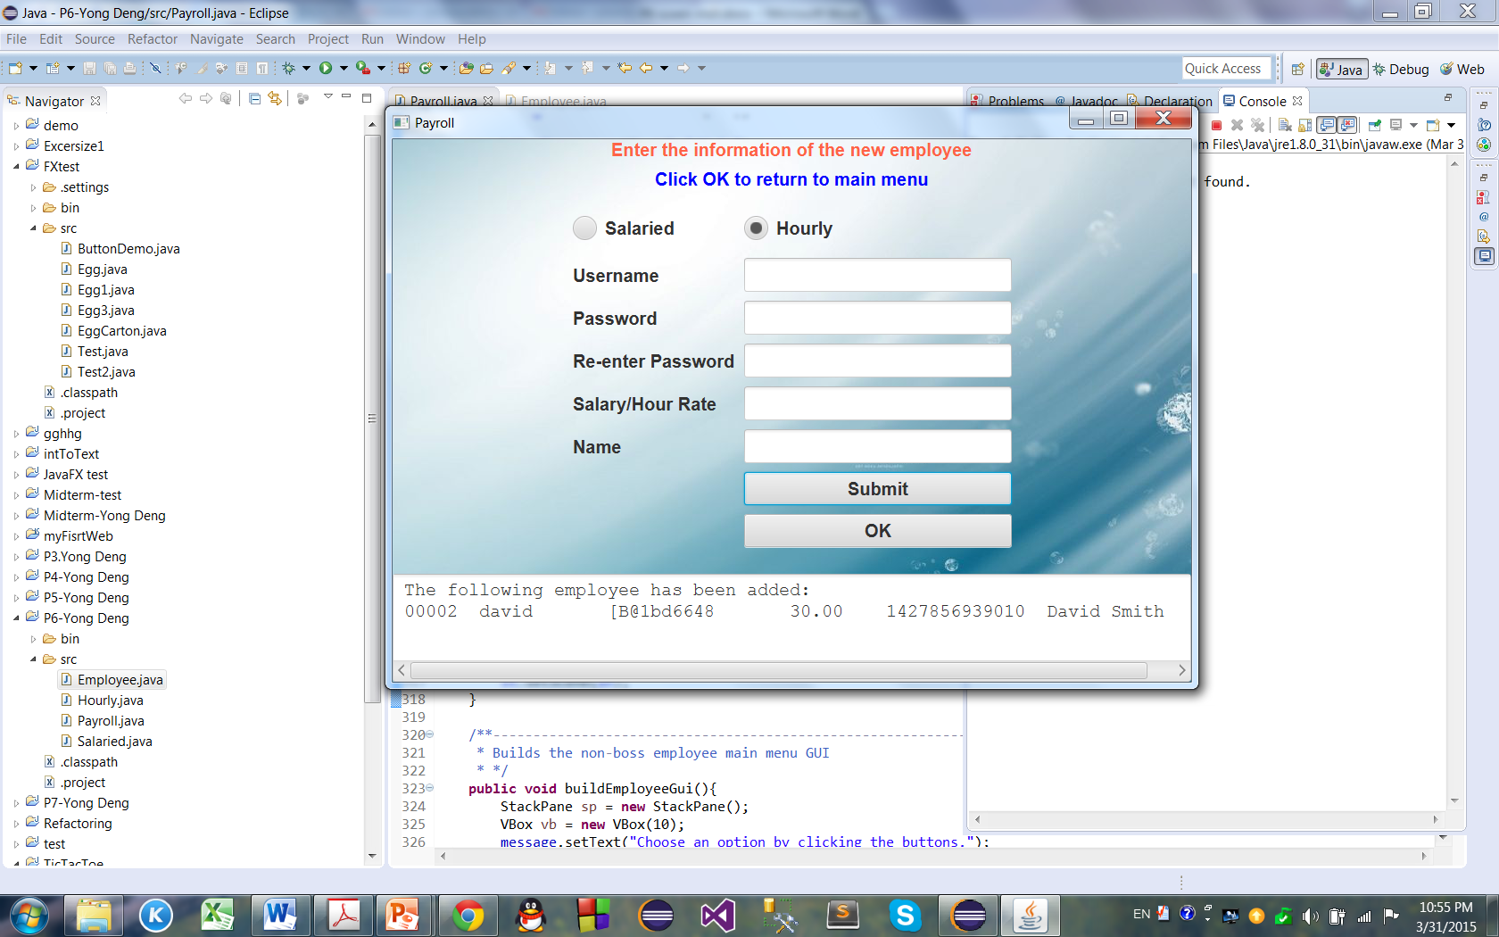

6. The boss clicked “OK” to go back to main menu:

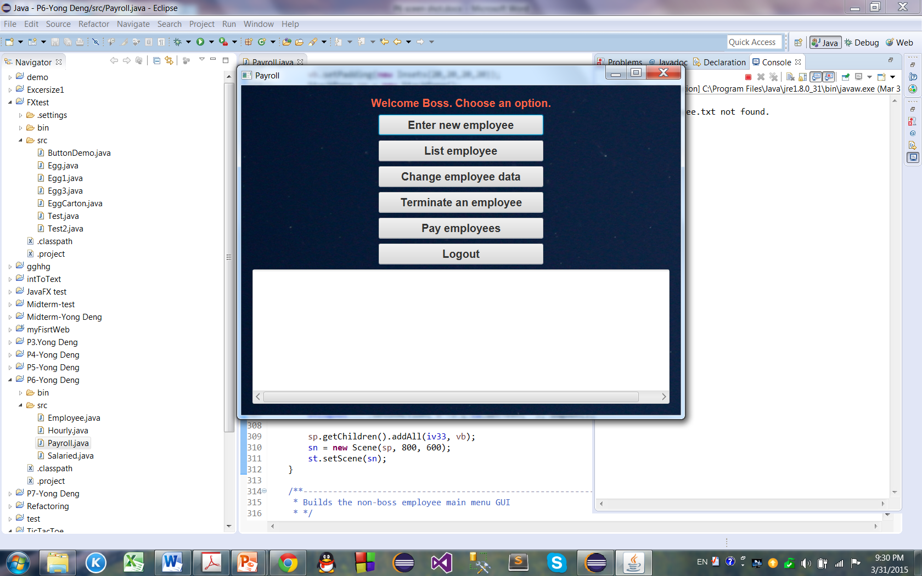

7. The boss listed the employees:

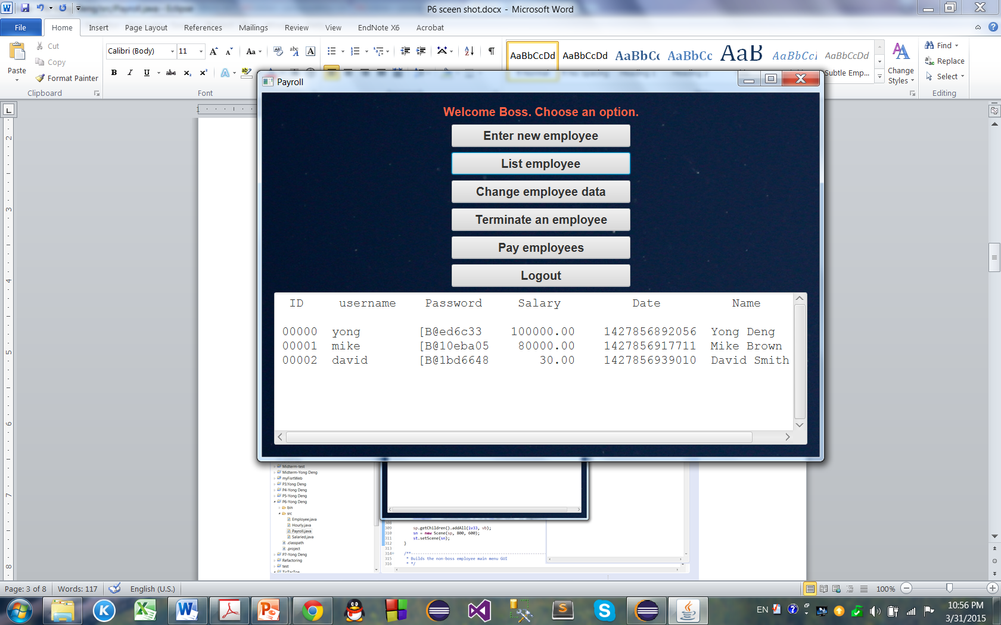

8. The boss then logged out:

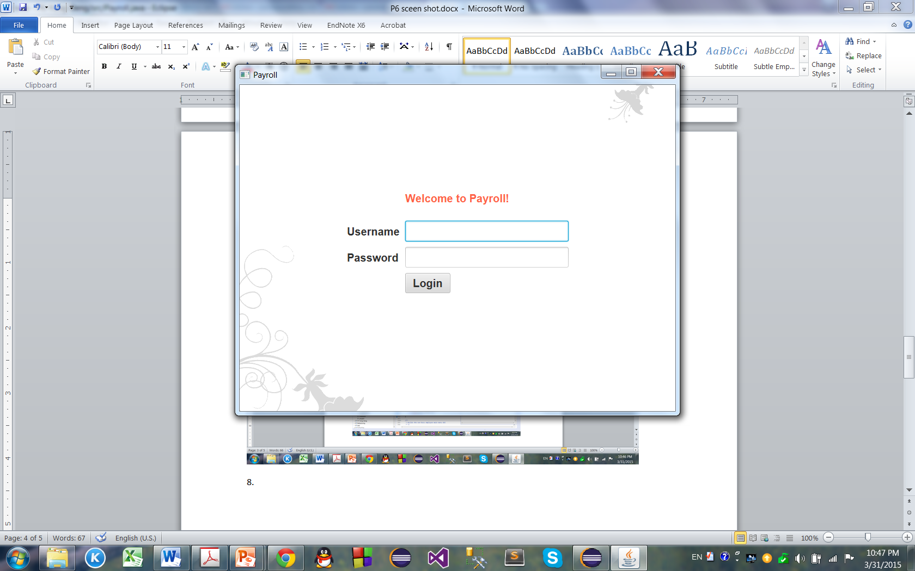

9. The boss logged in again:

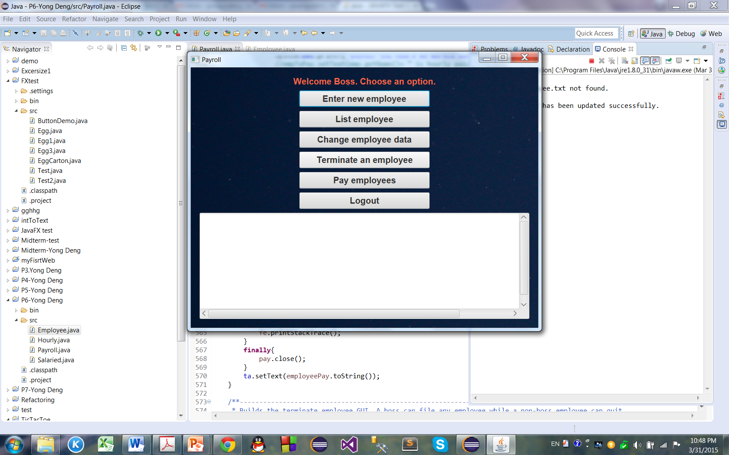

10. The boss listed the employees:

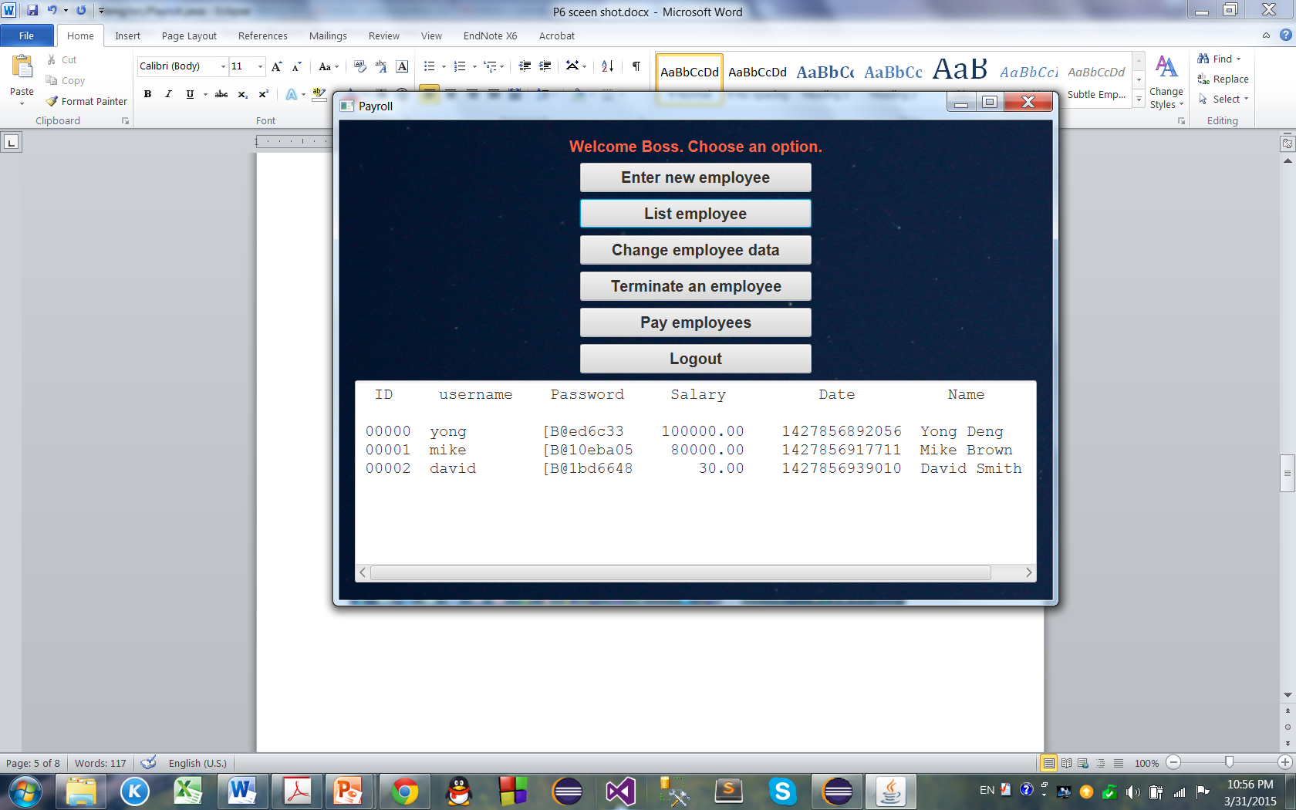

11. The boss then changed the name and salary of employee Mike Brown to Mike White, salary to 85000:

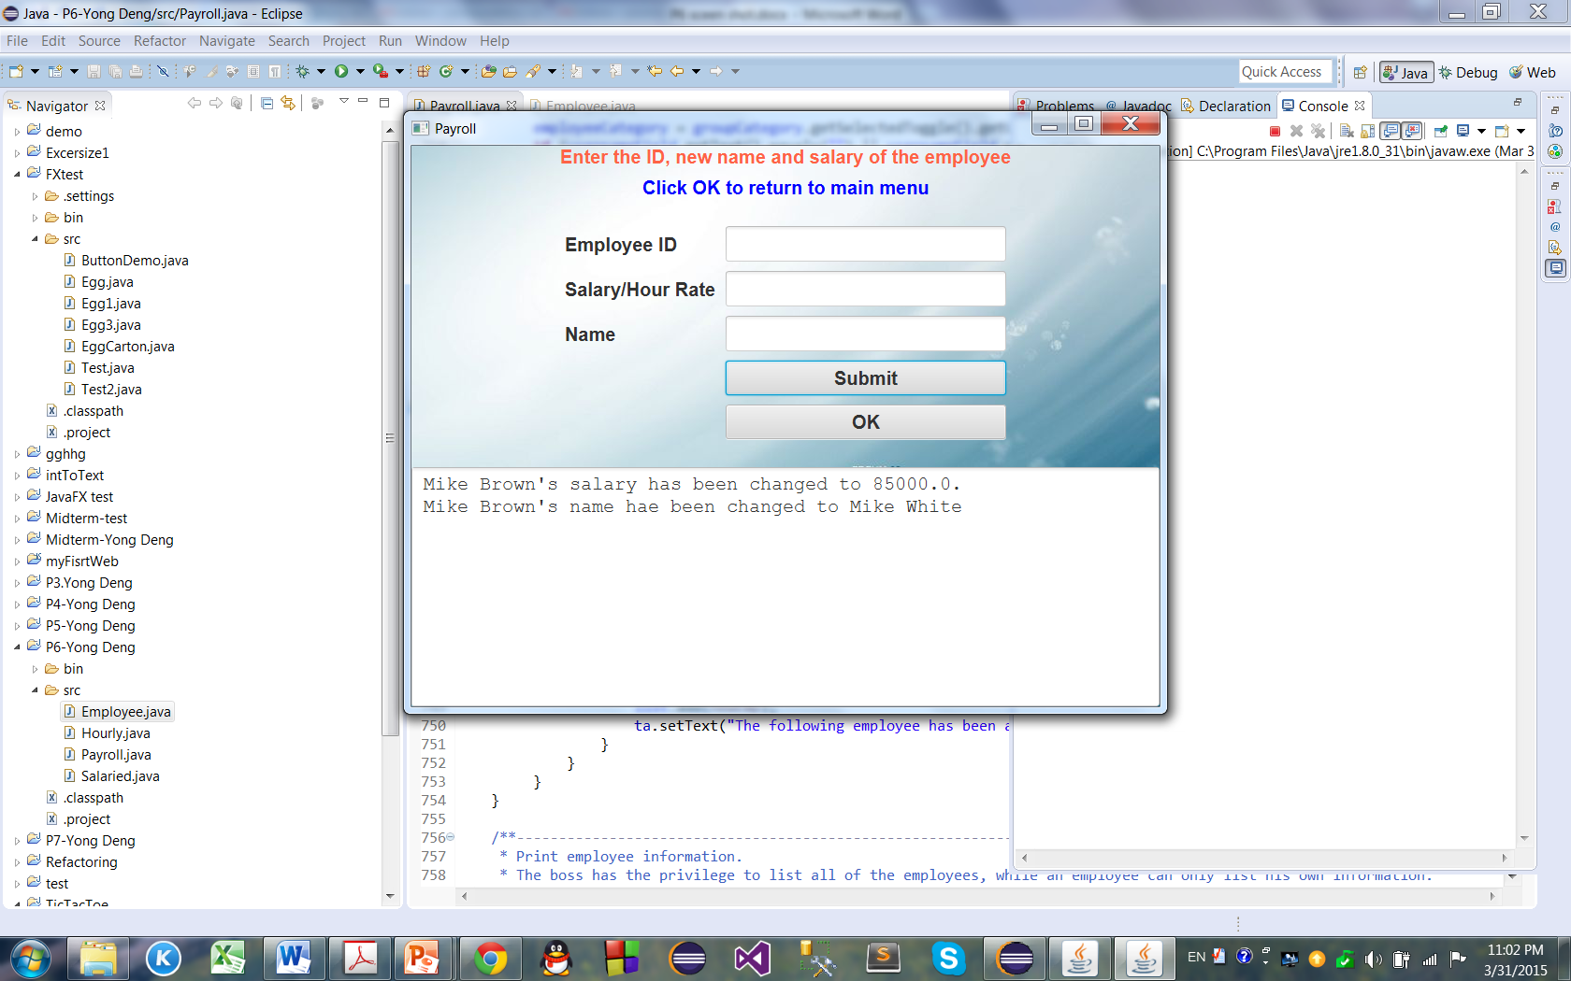

12. The boss goes back to main menu:

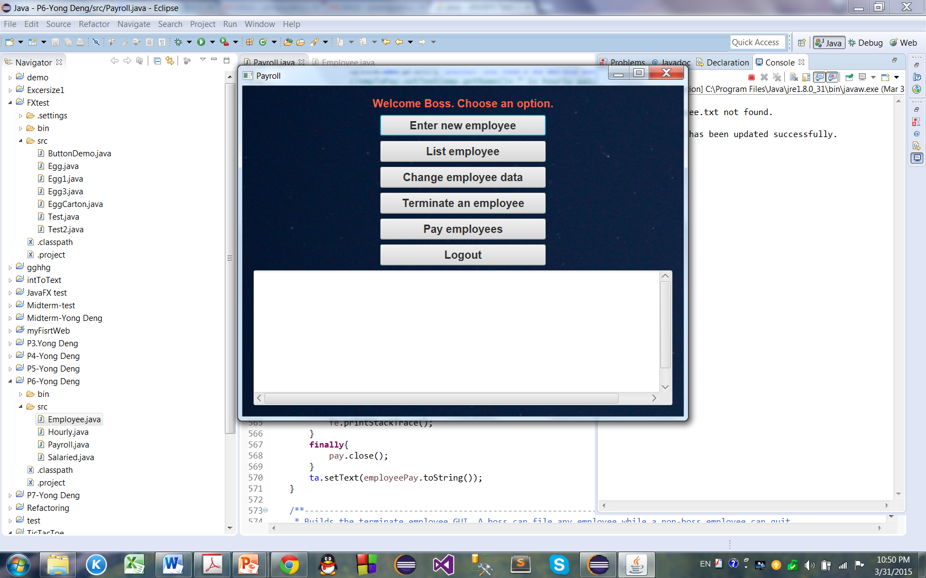

13. The boss then pays employees:

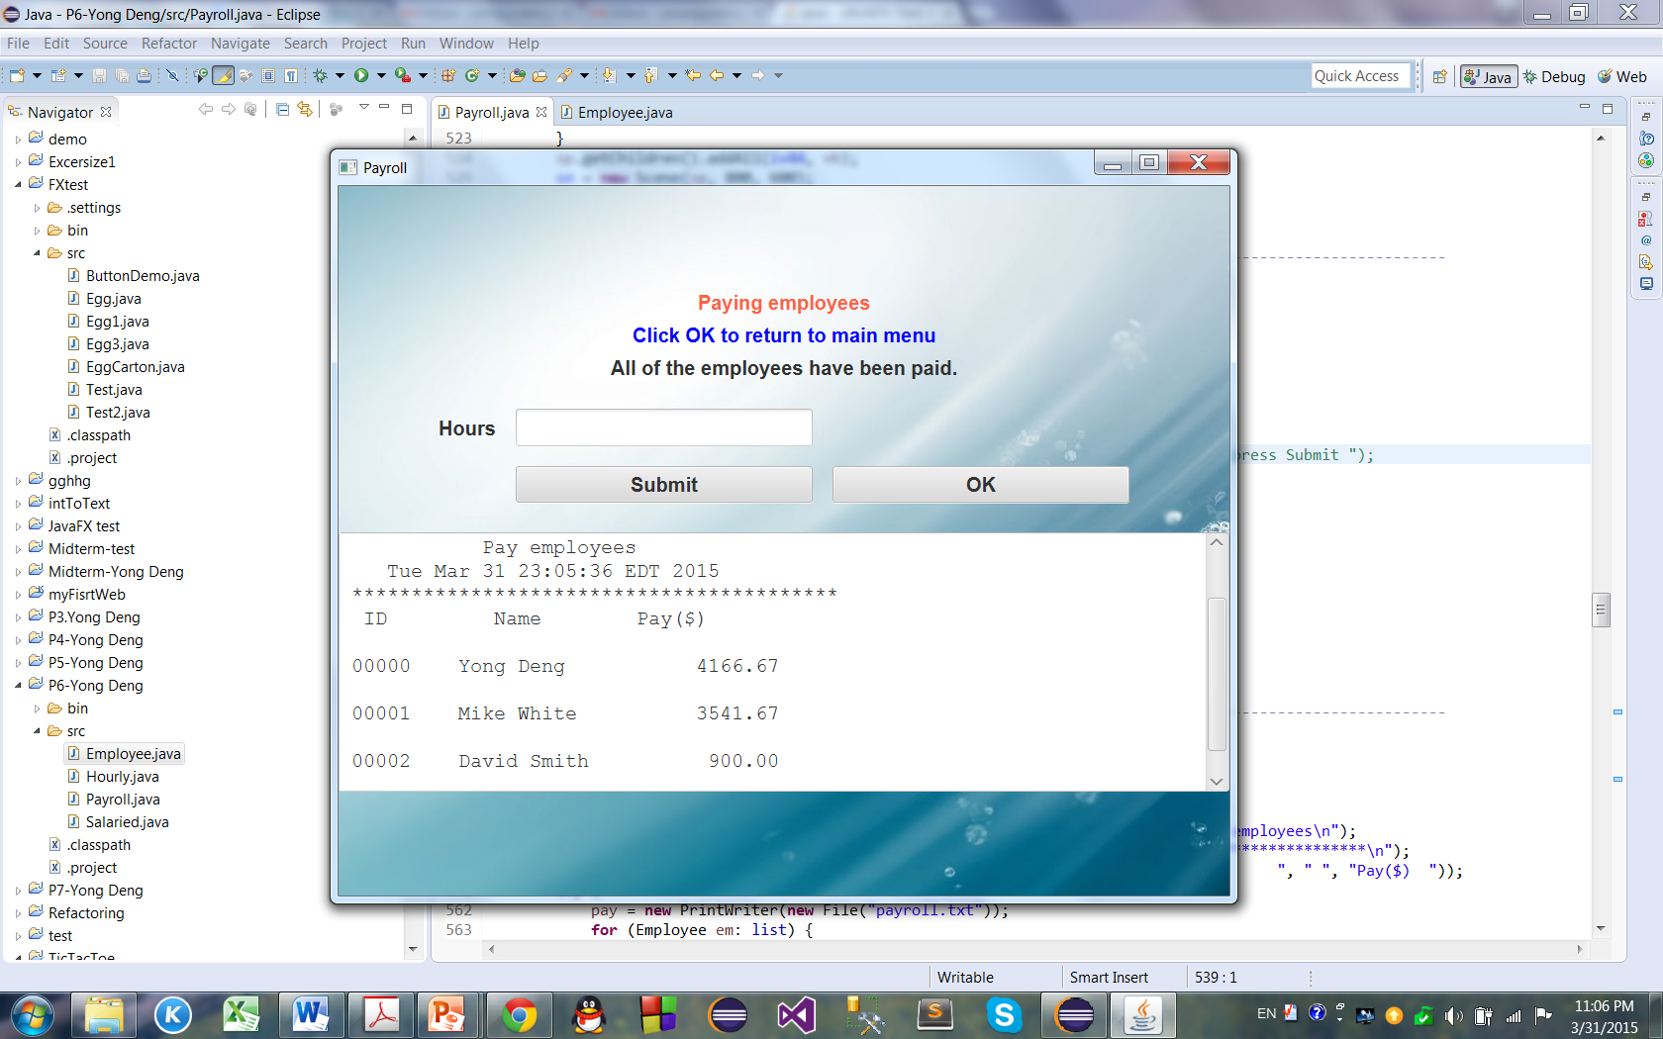

14. The boss then goes back to main menu and then goes to terminate employee (ID: 00001 Name: Mike White):

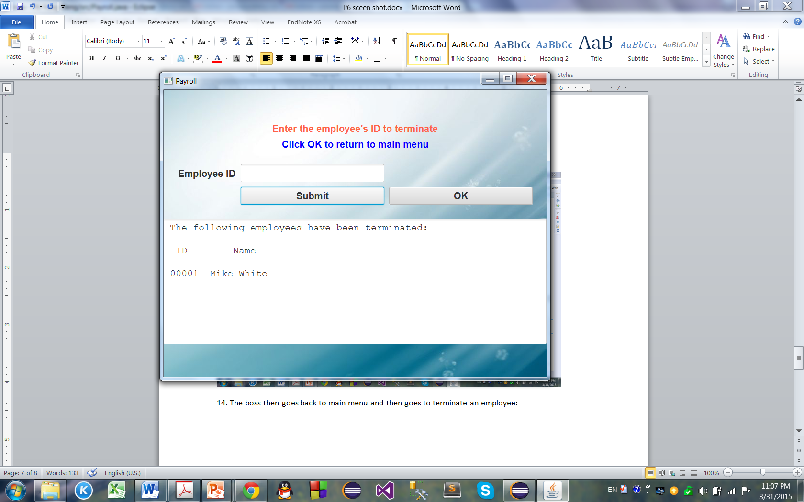

15. The boss then goes back to main menu, adds two more employees and lists employees:

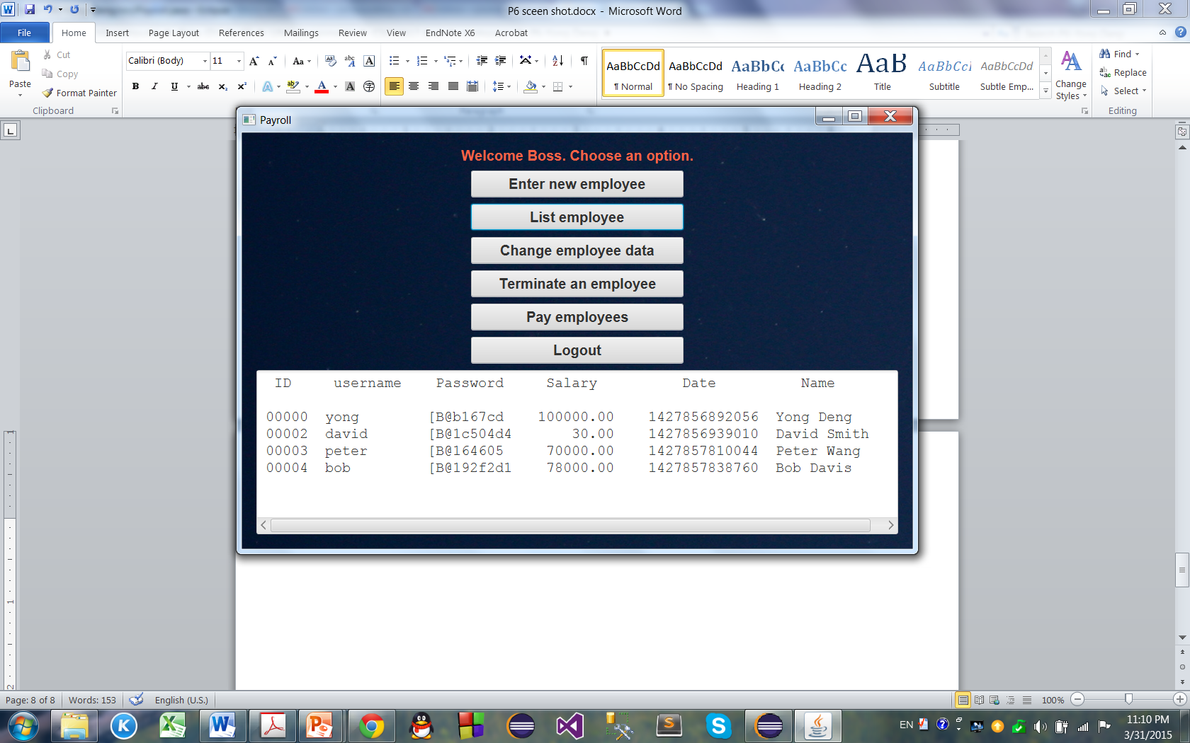

16. The boss logs out.

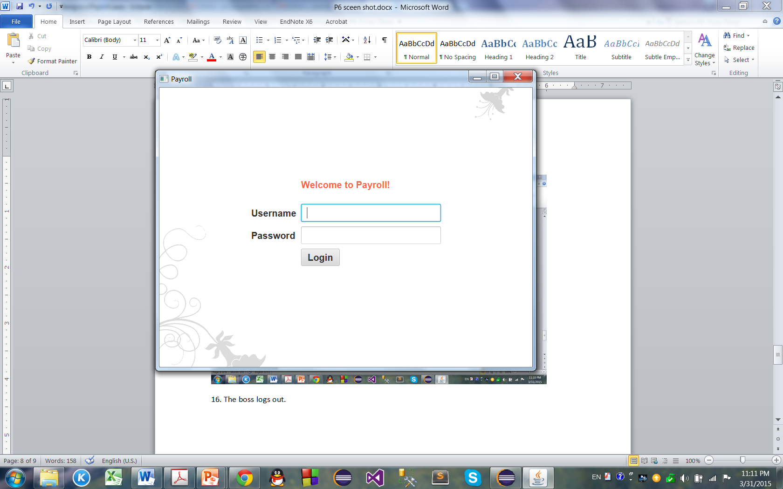

17. Employee David Smith (ID: 00002) logs in:

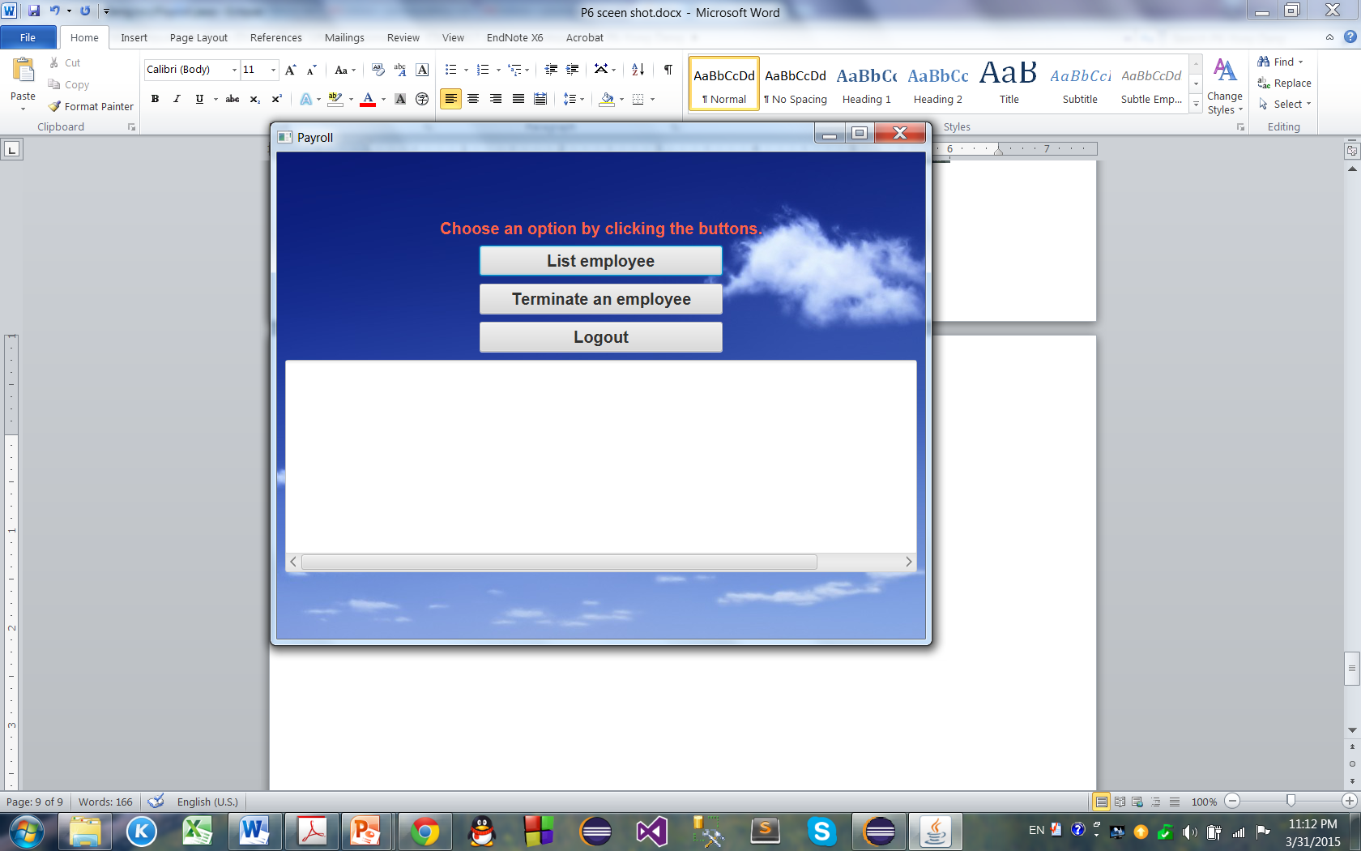

18. David lists his own data:

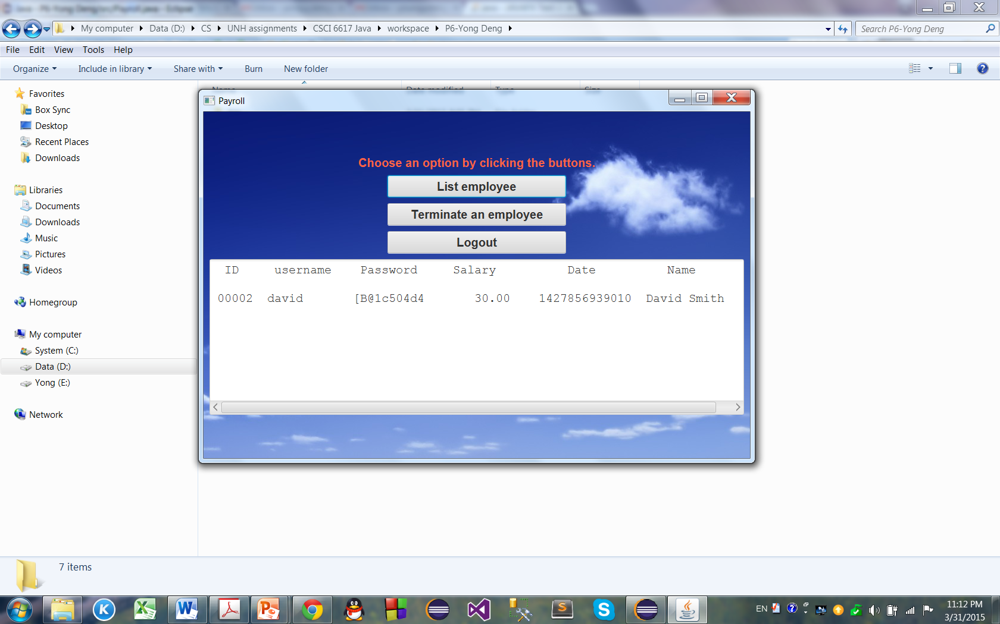

19. David tries to quit:

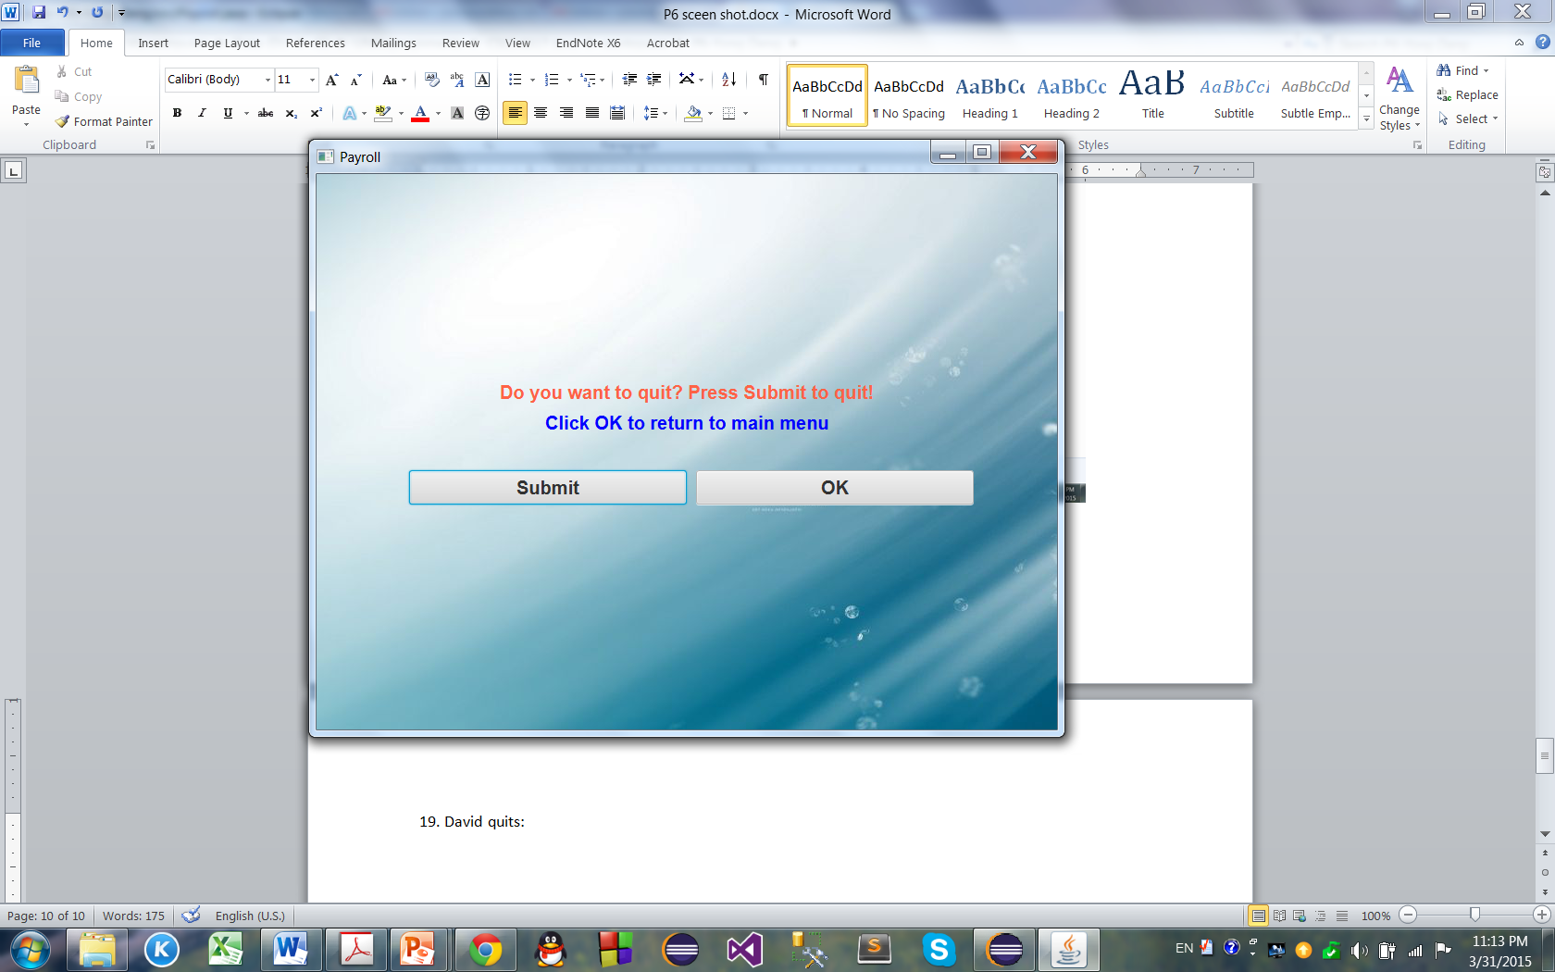

20. When David presses submit, the system goes back to log in screen:

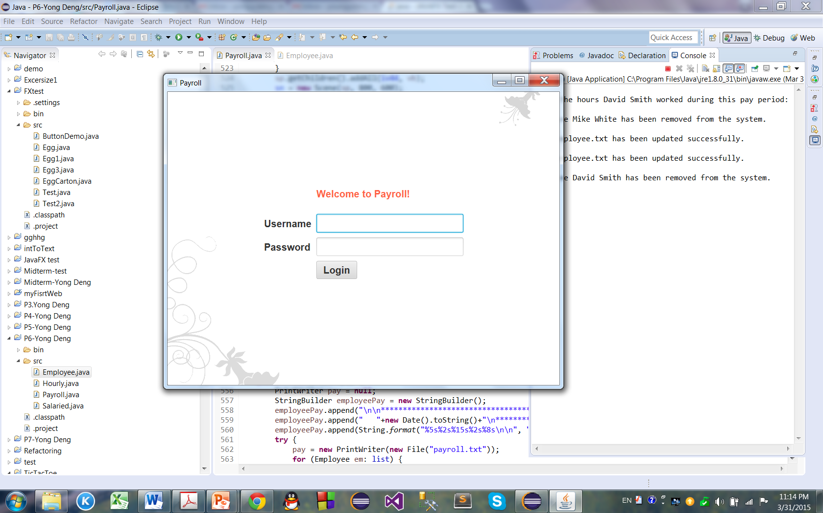

21. When David tries to log in again, he cannot:

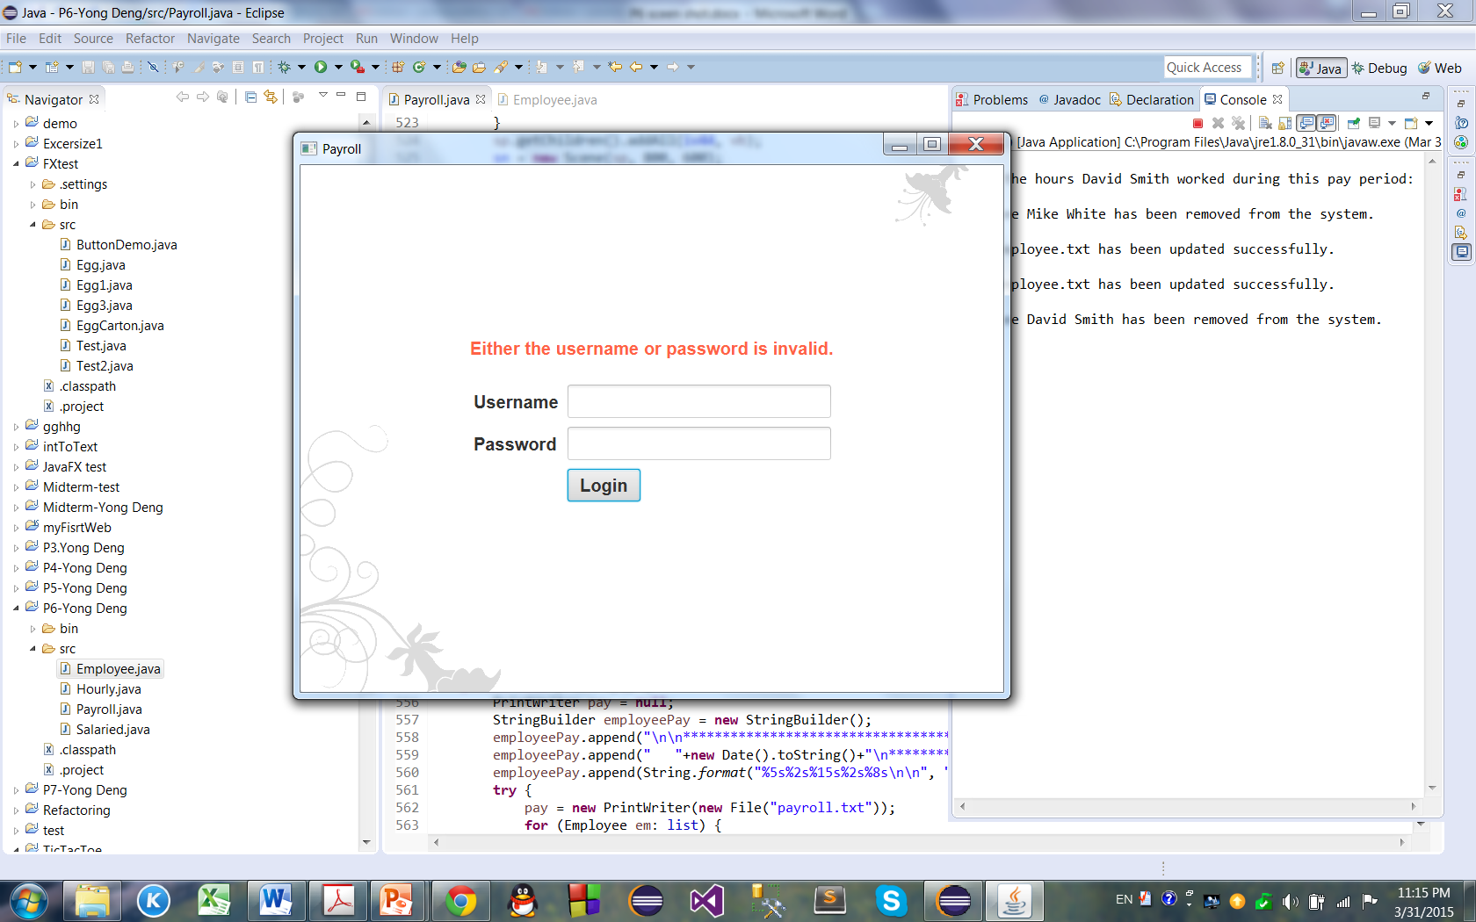

22. The boss then logs in and list employees:

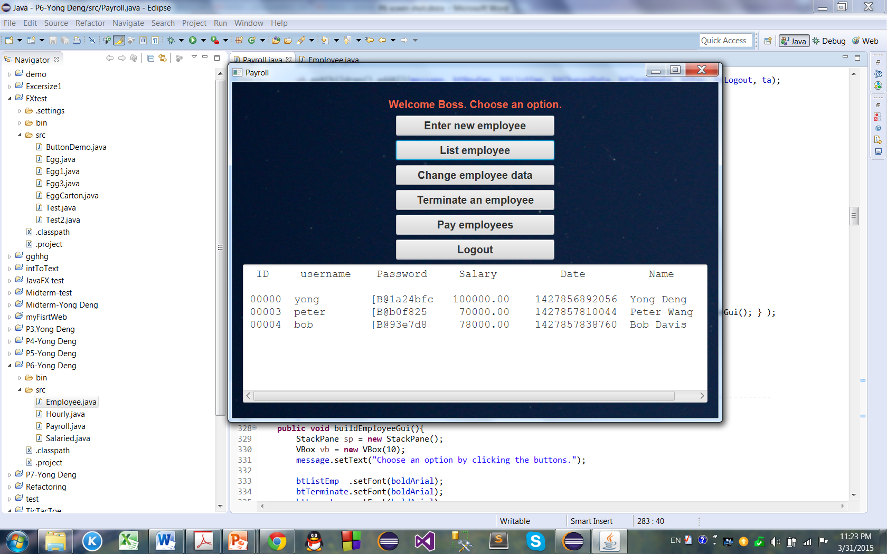

23. The boss pays the employees again:

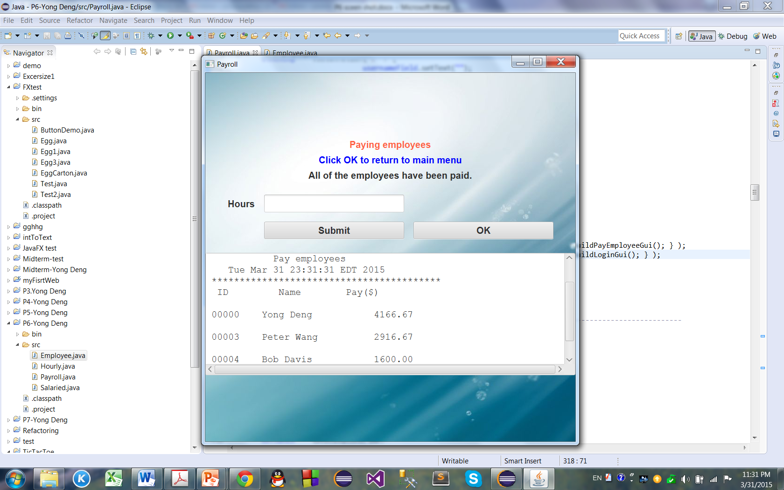

24. The boss logs out:

